Faculty of Computers and Artificial Intelligence Cairo University

Data Warehouse Term Project

**Project Name**

Mega Store

Phase 2

**Prepared for**

Eng\Alaa Adel

**Prepared By**

|  |  |
| --- | --- |
| **ID** | **Name** |
| 20200026 | Ahmed Abdelhameed |
| 20200456 | Mohamed Attef |
| 20200196 | Ziad Osama |
| 20201189 | Nada Emad |
| 20201191 | Nada Mohamed |

**Modified ERD**

1. **Control flow**

Loading the date from Excel sheets to OLE DB(SRC)

Loading the STG tables then dimensions

Loading the fact tables

**2. Data flow**

STG_Customer table: Using Look up to get the city name fromt table address full address and then get the city name from table city and get the store name from table Store and use derived column to get the current date

**3. Load CustomerDIM**

Condition split if the current last update column greater than variable in SSIS named LastUpdateTime and look up to check if this record is already exist or no. then if exist write OLE Query to update the End date and then insert the record then use derived column to get the Current date then sort the data by customer ID (asc) then load to the DIM

Load Employee to STG_Employee using look up to get full address then city name then store name and get the Current date as derived column

Condition split if the current last update column greater than variable in SSIS named LastUpdateTime and look up to check if this record is already exist or no. then if exist write OLE Query to update the End date and then insert the record then use derived column to get the Current date then sort the data by employee ID (asc) then load to the DIM

Loading STG_Store using lookup to get the full address and then City name and store name from (Store table) and Current date as derived column

Loading Store Dim. Condition split if the current last update column greater than variable in SSIS named LastUpdateTime and look up to check if this record is already exist or no. then if exist write OLE Query to update the End date and then insert the record then use derived column to get the Current date then sort the data by Store ID (asc) then load to the DIM

Load the STG_Product using lookup to get the full category name and current date as derived column.

Loading Product Dim. Condition split if the current last update column greater than variable in SSIS named LastUpdateTime and look up to check if this record is already exist or no. then if exist write OLE Query to update the End date and then insert the record then use derived column to get the Current date then sort the data by Product ID (asc) then load to the DIM

Load STG_Location using look up to get the city name and current date as derived column

Load DIM_Location and assuming that it won’t be slowly changing dim we will check just check if it’s a new record or not as it’s expected that the End date will not change

Load STG_Employee_Performance using lookup to get store ID from table Store and then group by Store ID, Employee ID and date then Sum the amount sold

Load the Fact table Employee_Perfomance using conditional split to check if it’s a new record or not then look up the DIM_Date to get the date key and then lookup to DIM_Employee to get the Employee key and get the Store key from DIM_Store

Load STG_Sales_Customer using look up to get the price of some product id then calculate the price * quantity sold then group by customer id and payment date and product id then get the current date as a derived column

Load the Fact table Fact_Sales_Customer using conditional split to check if it’s a new record or not then look up the DIM_Date to get the date key and then lookup to DIM_Customer to get the Customer key and get the Product key from DIM_Product

Load STG_Inventory group by product ID and Address ID and then sort by total amount then current date as derived column.

Load Fact table Fact_Inventory if it’s a new record and get the date key from DIM_Date and then get the Address key from DIM_Location then the Product key from DIM_Product

**Queries**

**Query1: for Employee Performance fact table to get the best employee that sell maximum amount in some Year (variable in SSIS).**

select Top 1 Fact_Employee_Performance.EmployeeID, Dim_Date.Month, sum (Amount) as Amount

from Fact_Employee_Performance, Dim_Date

where Dim_Date.DateKey = Fact_Employee_Performance.DateID and Dim_Date.Year >=?

group by Dim_Date.Month, Fact_Employee_Performance.EmployeeID

order by Amount Desc

**Query2: This query gets the lowest product in my inventory which I should increase**

SELECT Top 1 ProductID, LocationID, Min (Amount) AS Total

FROM Fact_Inventory

GROUP BY ProductID, LocationID

ORDER BY Total

**Query3: used to select the top customer to get some offers**

SELECT TOP (1) Fact_Sales_Customer.CustomerID, Fact_Sales_Customer.ProductID, SUM(Fact_Sales_Customer.Total) AS Total

FROM Fact_Sales_Customer INNER JOIN

Dim_Date ON Fact_Sales_Customer.DateID = Dim_Date.DateKey

WHERE (Dim_Date.[Year] >= ?) AND (Dim_Date. [Month] =?)

GROUP BY Fact_Sales_Customer.ProductID, Fact_Sales_Customer.CustomerID

ORDER BY Total DESC

**Deployment**

Deployment of the queries of each fact table

The schedule for the tasks weakly every sun date at 12:00:00AM

**Package result**

**best employee**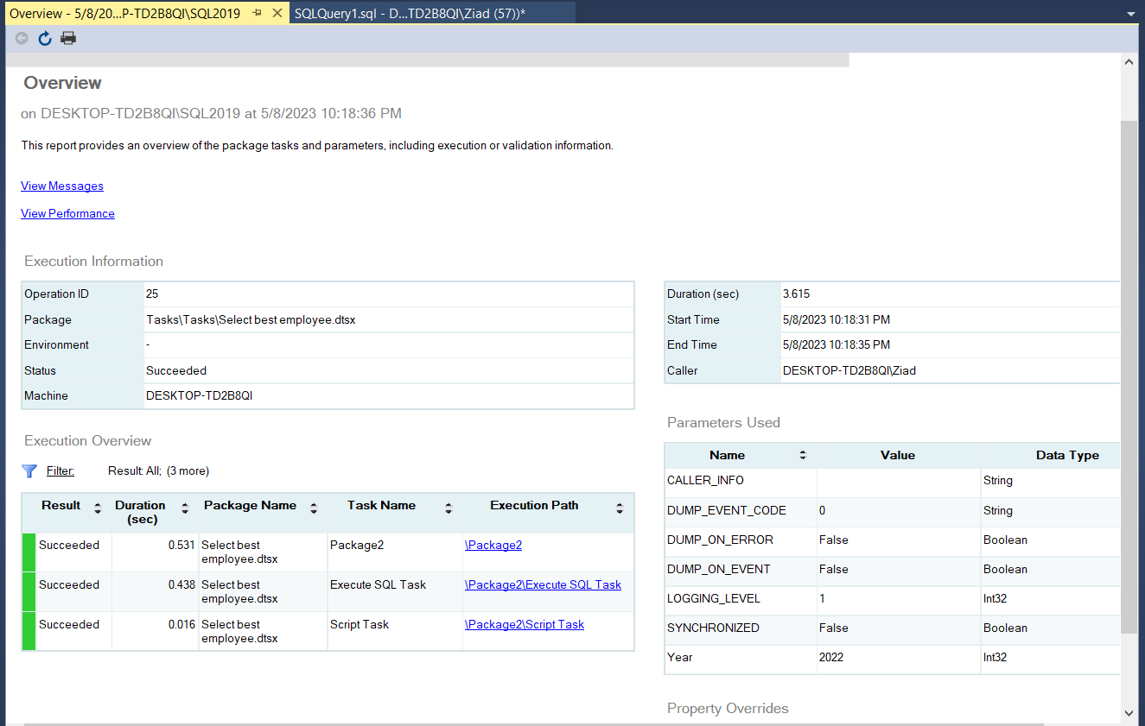

**Lowest product**

**Best Customer**

**Bonus: -**

**Interactive dashboard for the DWH (BI tool)**

